PRACTICE 2.1: USING JDBC CONNECTORS FOR MYSQL

OBJECTIVE: CONNECT AN APPLICATION TO MYSQL

PRACTICE: This practice has several steps:

1. Install MySQL in our machine: We will install it with the XAMPP distribution
2. Create a small table (to access it later) (table STUDENTS):
3. Download de jdbc connector
4. Write our program to try the connection.

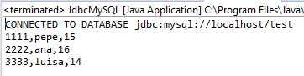

STEP 1: Install XAMPP.

Note: the error UAC tells you not to install on Windows86 folder. You may have errors or conflicts with ports because of VMWare or other. It’s not important for our practice, if you can start Apache and MySQL.

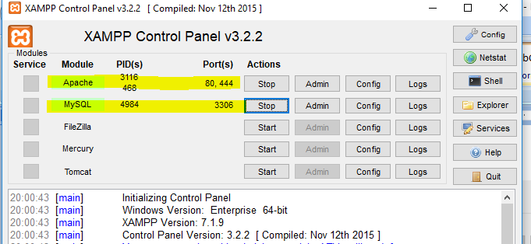

ACCESS IT ON THE BROWSER: type localhost/phpmyadmin (phpmyadmin is a graphic tool to access MySQL)

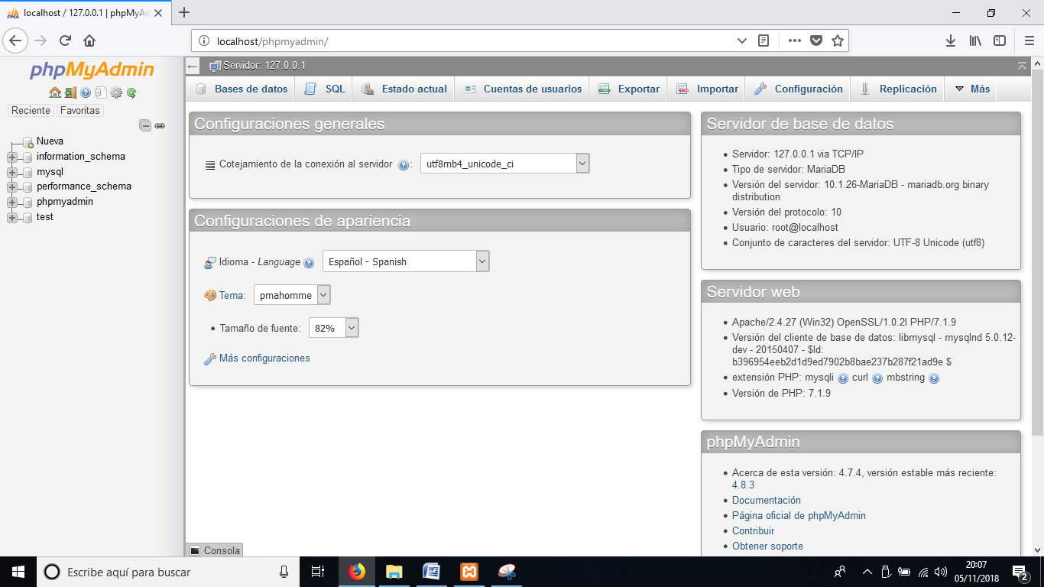

STEP2: Create a small table to access it later (table STUDENTS) in our application: Our table can be created graphically or writing the SQL text directly.

In the database TEST we will create a table STUDENTS: it will have 3 fields

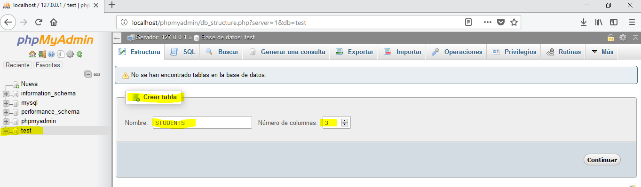

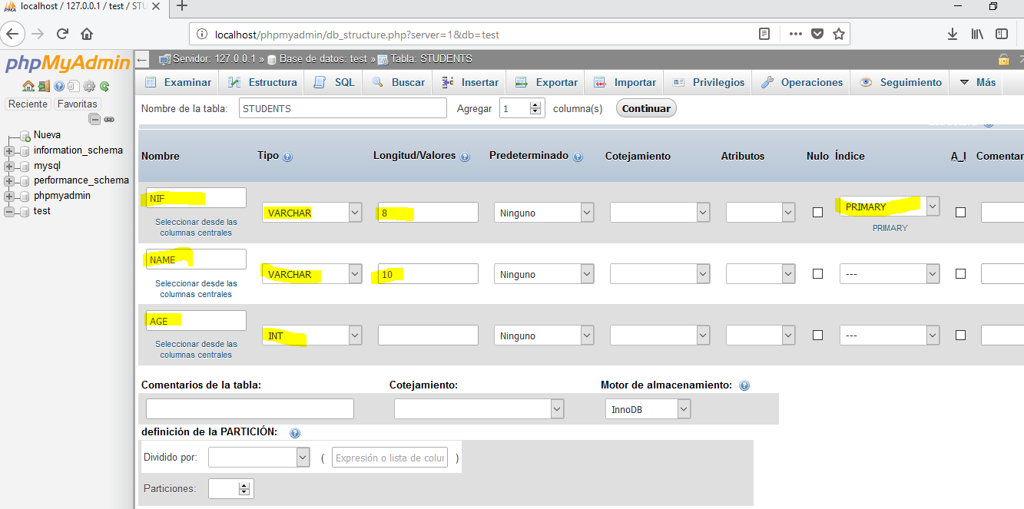

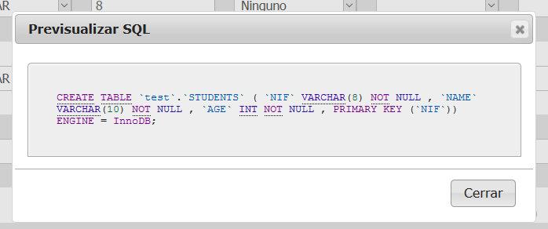

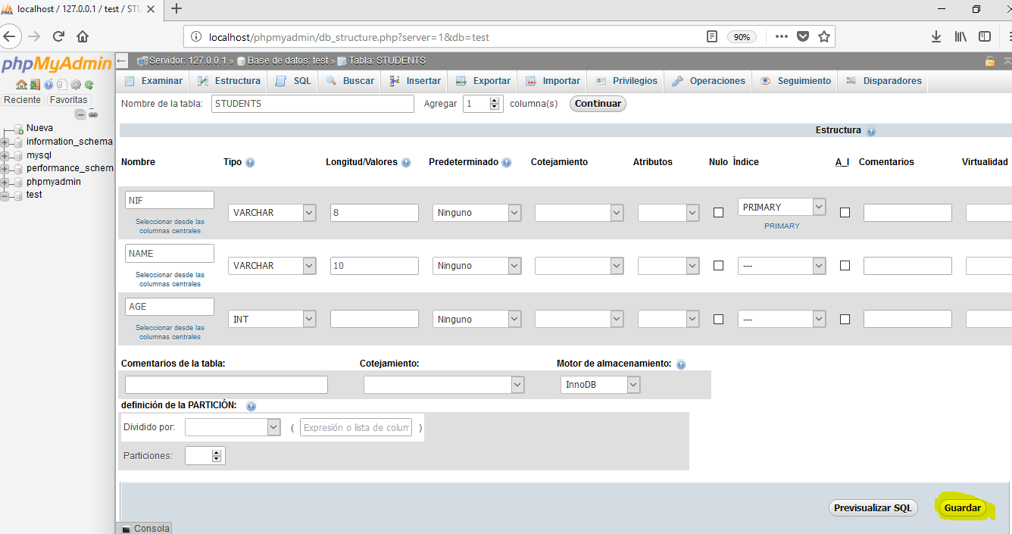

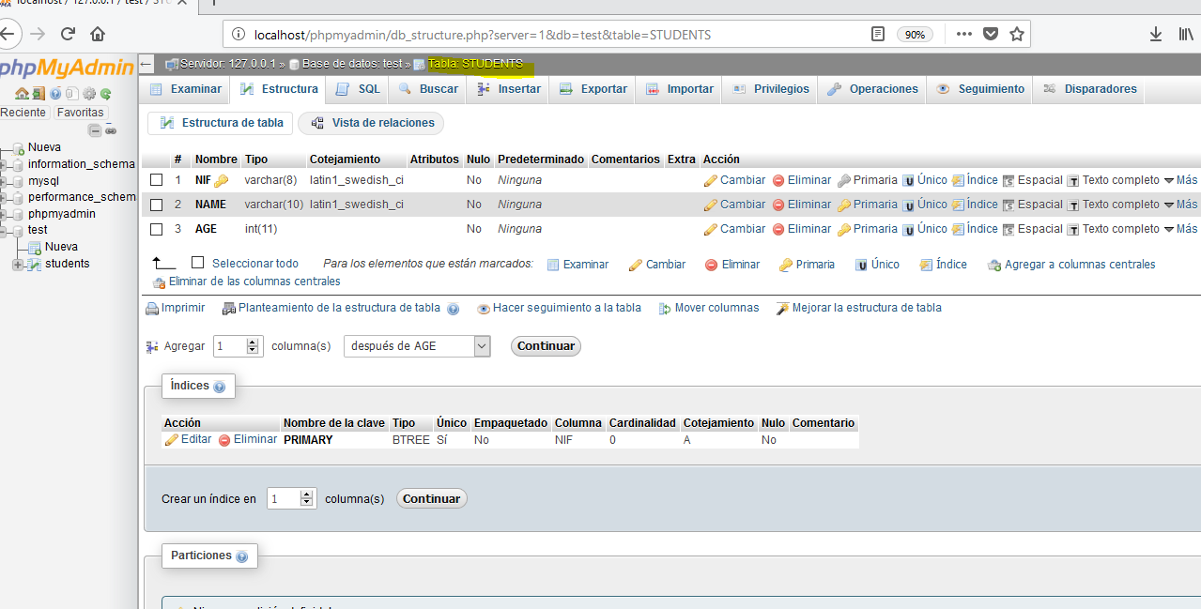

Now we can add students to our table:

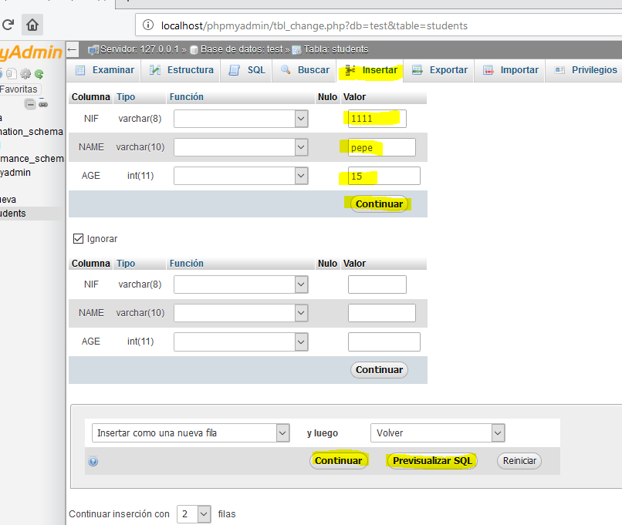

Then we have our data in the table students

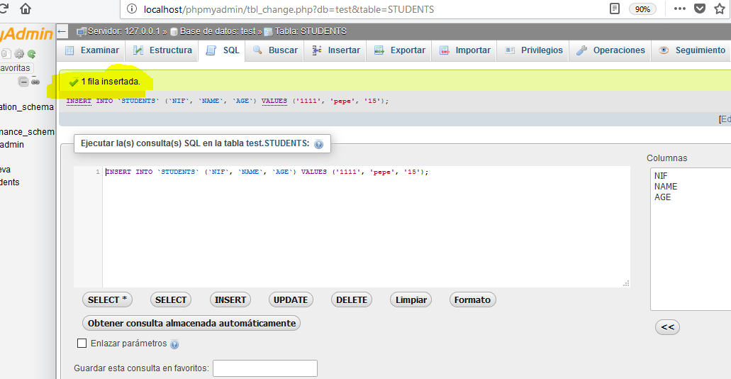

Insert 3 values (or more if you want) repeating the process.

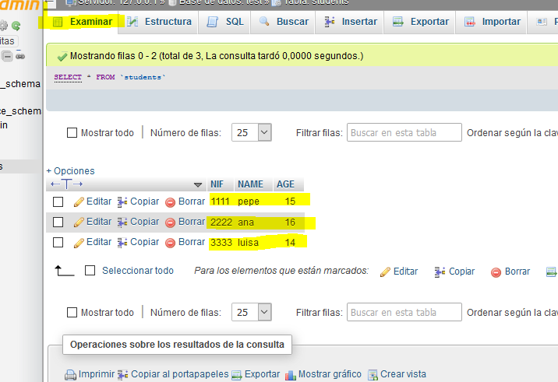

This table is the one we will use for our connection.

STEP 3: DOWNLOAD THE JDBC CONNECTOR

Get the file ***mysql-connector-java-5.1.18.jar***

Add the jar file to your new Project with the option “Build Path”:

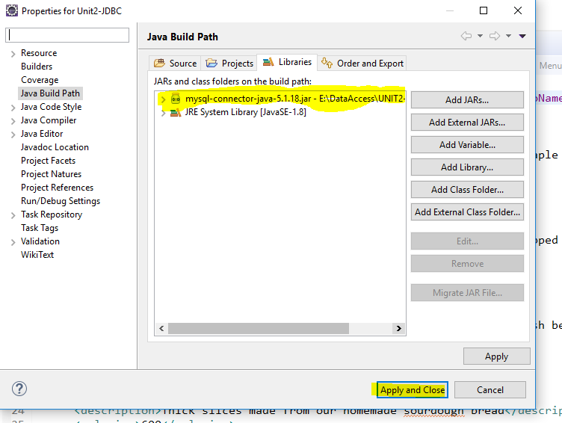

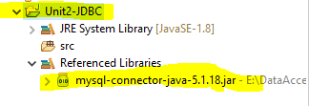

STEP 4. Write our program to try the connection.

We will use the package java.sql.*;

The classes used for the connection to the database are:

**import** java.sql.*;

**public** **class** JdbcMySQL {

**public** **static** **void** main(String[] args) {

//String url="jdbc:mariadb://localhost/test";

String url="jdbc:mysql://localhost/test";

**try**{

//Class.forName("org.mariadb.jdbc.Driver");//it also works for MySQL in XAMPP. We need the driver for mariadb

Class.*forName*("com.mysql.jdbc.Driver");

//User="root", password="" in MySQL, cadena is the url of the database

//Open the connection with the 3 arguments (url,user,password)

Connection conexion=DriverManager.*getConnection*(url,"root","");

//if the connection fails, there is an exception here

System.***out***.println("CONNECTED TO DATABASE "+ url);

//Create the SQL sentence to execute in the database

Statement sentence=conexion.createStatement();

String sql="SELECT * FROM students";

//execute the sentence, obtaining a relset

ResultSet resul=sentence.executeQuery(sql);

//process the resulset with the methos resul.next()

**while**(resul.next()){

System.***out***.printf("%d,%s,%s %n",resul.getInt(1),resul.getString(2),resul.getString(3) );

}

//result.getInt(nif), resul.getString(name), resul.getString(age) también funciona

//close the objects

resul.close();

sentence.close();

//close the connection

conexion.close();

}**catch**(Exception e){

e.printStackTrace();

}

}

}

Before running your program, xampp must be on(we need Apache and MySql running).

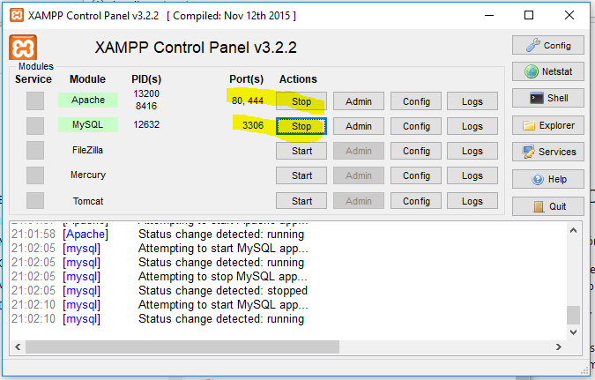

When you run your program, you must get something like this:

